  - Secure Cloud Login Monitoring and Suspicious Access Alert System
Final Project Report

Student Name: Yousef Moayyad Alkderat
ID: 20210286
Course Name: Cloud Computing & Security
Course Code: 25541
Submission Date: 13/5/2026

Abstract
This project presents a cloud-based login monitoring system that detects suspicious access attempts and alerts the administrator when risky behavior is found. The system was designed as a simple but practical security prototype for small web systems and student projects. A local HTML interface sends login requests to an Amazon API Gateway HTTP API, which forwards them to an AWS Lambda function. The Lambda function checks the login details, applies rule-based suspicious access checks, stores the result in Amazon DynamoDB, records execution logs in Amazon CloudWatch, and sends an email alert through Amazon SNS when a suspicious attempt is detected. The final prototype uses multiple cloud services in an end-to-end workflow and demonstrates serverless cloud engineering, monitoring, alerting, and access control. Testing showed that the system correctly handled both normal and suspicious login attempts. For example, a normal login using a valid test account was processed successfully, while a login using a suspicious username such as admin was flagged and triggered an alert email. The project shows how cloud services can be integrated to build a lightweight security monitoring system using clear and explainable rules.

1. Introduction

1.1 Problem Description
Many web applications allow users to log in, but small systems often do not monitor suspicious login behavior in a structured way. Repeated failed attempts, common attacker usernames, and unusual input may go unnoticed if the system only checks whether the password is correct. This creates a security risk because brute-force and password-spraying style behavior can continue without detection.

1.2 Motivation
The motivation behind this project was to build a small and understandable cloud security system that goes beyond a basic login form. Instead of focusing only on successful or failed authentication, the project also records login behavior, marks suspicious attempts, and alerts the administrator in real time. The design was kept simple on purpose so that each step could be clearly explained and demonstrated.

1.3 Project Focus
This project combines both Cloud Computing and Cloud Security. It uses several AWS services and applies security monitoring to login activity.

1.4 Objectives
- Build a working login monitoring prototype using AWS cloud services.
- Detect suspicious login activity using simple rule-based checks.
- Store login attempts and their results in a cloud database.
- Record logs for monitoring and debugging.
- Send an email alert when suspicious access is detected.
- Document the system design, implementation, and testing results clearly.

2. Cloud Architecture

2.1 Cloud Provider and Services Used
The system was implemented on Amazon Web Services (AWS). The final prototype used six AWS services: Amazon API Gateway, AWS Lambda, Amazon DynamoDB, Amazon CloudWatch, Amazon SNS, and AWS IAM. Together, these services formed a serverless security monitoring workflow.
Service | Role in the Project | Why It Was Chosen
Amazon API Gateway | Receives login requests from the frontend and forwards them to Lambda. | Simple way to expose a secure HTTP endpoint for the login API.
AWS Lambda | Processes login attempts and applies suspicious-access rules. | Serverless execution reduced setup complexity and matched the event-driven design.
Amazon DynamoDB | Stores login attempt records and results. | Managed NoSQL database suitable for lightweight application data.
Amazon CloudWatch | Stores function logs for monitoring and debugging. | Provides built-in visibility into Lambda activity and execution behavior.
Amazon SNS | Sends alert emails when suspicious activity is detected. | Simple event notification service that integrates well with Lambda.
AWS IAM | Controls permissions between AWS services. | Used to apply least-privilege access between Lambda, DynamoDB, SNS, and CloudWatch.

2.2 Architecture Diagram
Figure 1 shows the final system architecture. The local login page sends a request to API Gateway. API Gateway invokes the Lambda function, which stores results in DynamoDB, writes logs to CloudWatch, and sends alerts through SNS when necessary.
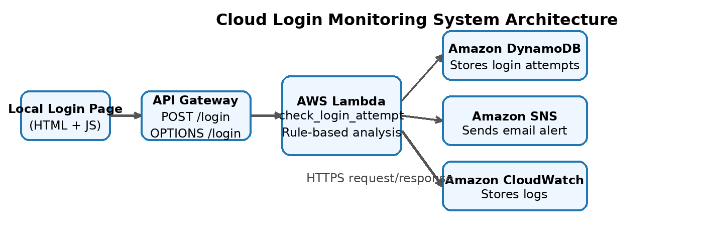
Figure 1. Final system architecture of the cloud login monitoring prototype.

2.3 Integration Flow and Deployment Model
The implementation uses a lightweight frontend and a serverless backend. During testing, the login page was served locally using a small Python HTTP server. When the user clicked Login, the browser sent a POST request to the API Gateway endpoint /login. API Gateway then invoked the Lambda function using a Lambda proxy integration. The function evaluated the request, saved the result in DynamoDB, and published an SNS message when suspicious activity was detected. Lambda logs were automatically sent to CloudWatch. The deployment model is therefore a hybrid of local frontend testing and cloud-hosted backend services.

3. Core Implementation

3.1 Main Components and Technologies
The frontend was written as a simple HTML and JavaScript page. The backend logic was written in Python inside an AWS Lambda function called check_login_attempt. The API layer was implemented using an API Gateway HTTP API with POST /login and OPTIONS /login routes. The DynamoDB table login_attempts stored the login records. Amazon SNS handled email alerts, and CloudWatch kept the execution logs.

3.2 How the System Works
- The user opens the login page and enters a username and password.
- The page sends the data as a POST request to the API Gateway endpoint.
- API Gateway forwards the request to the Lambda function.
- The Lambda function checks whether the credentials match the prototype user list and whether the behavior looks suspicious.
- The function stores the result in the DynamoDB table login_attempts.
- CloudWatch records function execution logs automatically.
- If the attempt is suspicious, Lambda publishes a message to SNS, which sends an email alert to the administrator.
- The response is returned to the browser and shown in the result box.

3.3 Screenshots and Example Outputs
The following figures show the implemented interface, successful and suspicious login behavior, stored database records, Lambda configuration, and monitoring/alerting outputs.

As shown in Figure 2, the system provides a simple login interface where the user enters a username and password before sending the request to the cloud backend. As shown in Figure 3, when the correct credentials are entered, the system processes the request successfully and returns a normal login result with no suspicious activity detected.
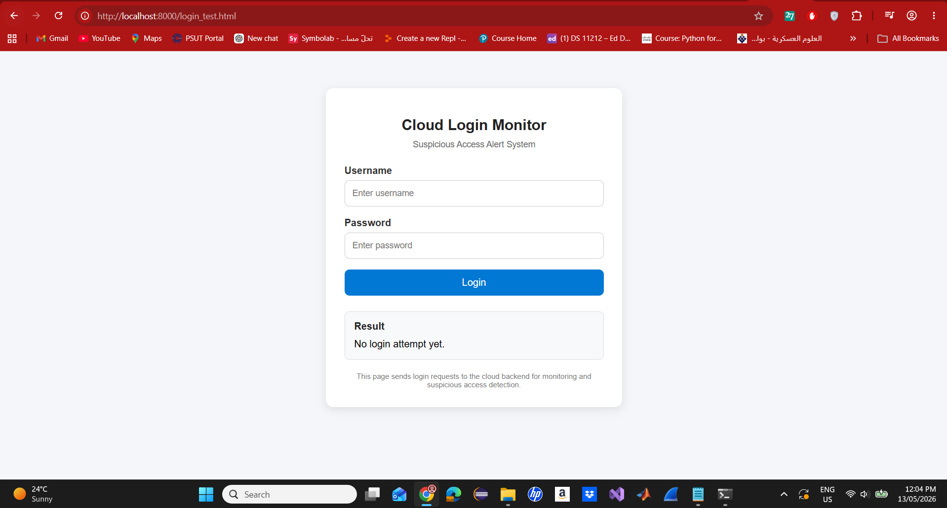
Figure 2. Final login page used for local testing.
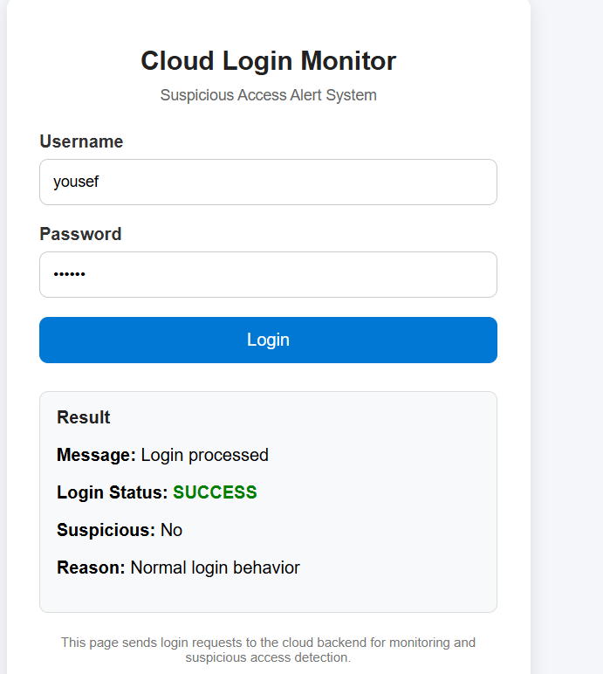
Figure 3. Successful login attempt using a valid test account.
As shown in Figure 4, when the username “admin” is used with incorrect credentials, the system marks the attempt as failed and suspicious because it matches one of the predefined suspicious usernames.
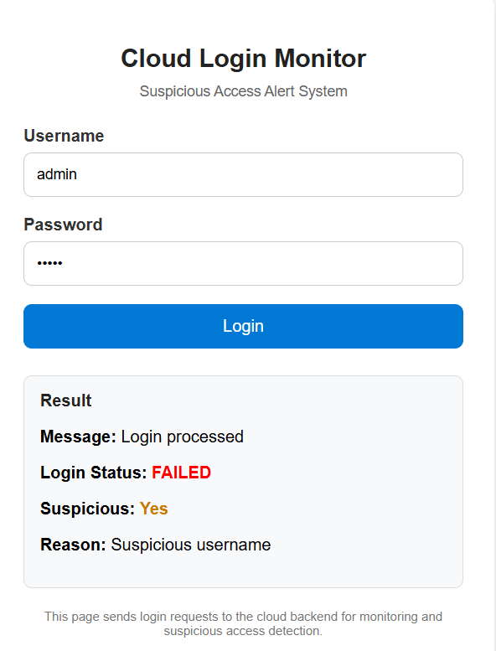
Figure 4. Suspicious login attempt using the username admin.

As shown in Figure 5, DynamoDB stores the login attempts with useful fields such as username, status, suspicious flag, and timestamp. This confirms that the backend records each login request correctly.
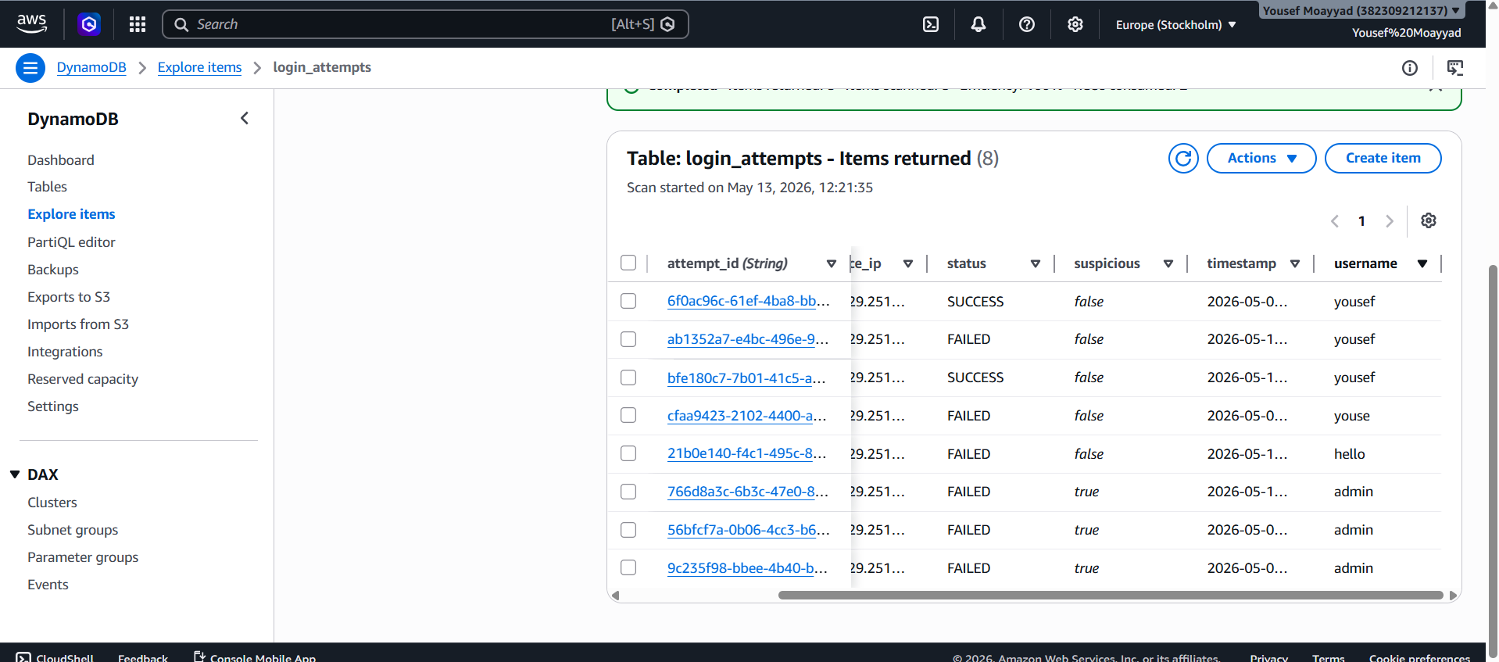
Figure 5. Login attempts stored in the DynamoDB table login_attempts.

As shown in Figure 6, the Lambda function contains the main backend logic of the system, including credential checking, suspicious login detection, saving records to DynamoDB, and sending SNS alerts.
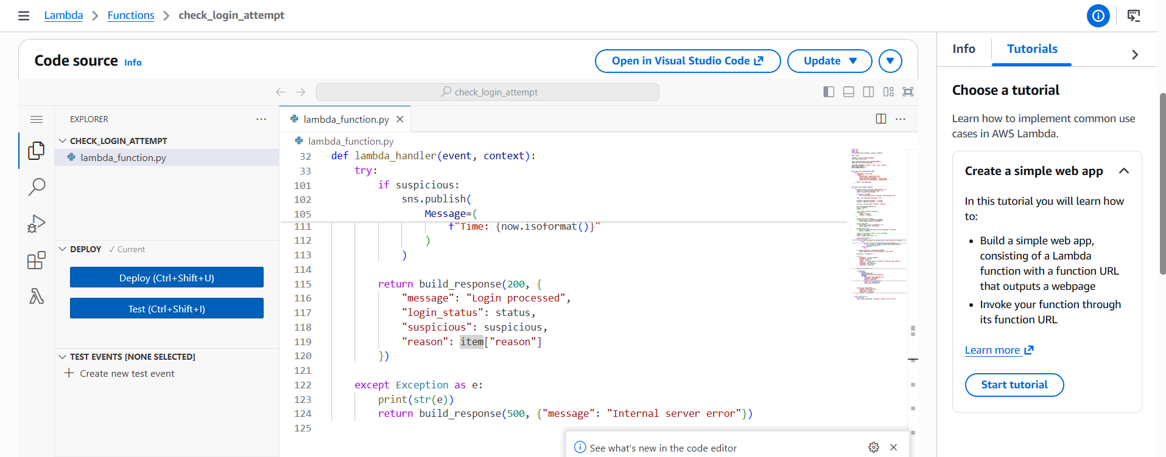
Figure 6. Lambda/code

As shown in Figure 7, API Gateway exposes the backend through the /login route and supports both POST and OPTIONS methods for request handling and browser compatibility.
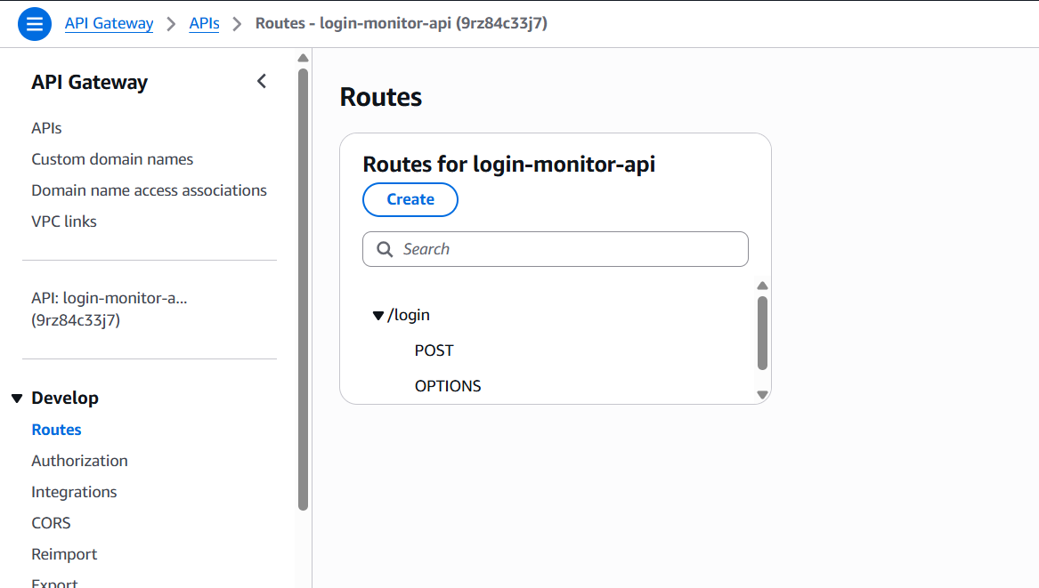
Figure 7. API Gateway routes configured for POST /login and OPTIONS /login.

As shown in Figure 8, the system sends an email alert when suspicious login behavior is detected. This helps the administrator notice risky activity quickly.
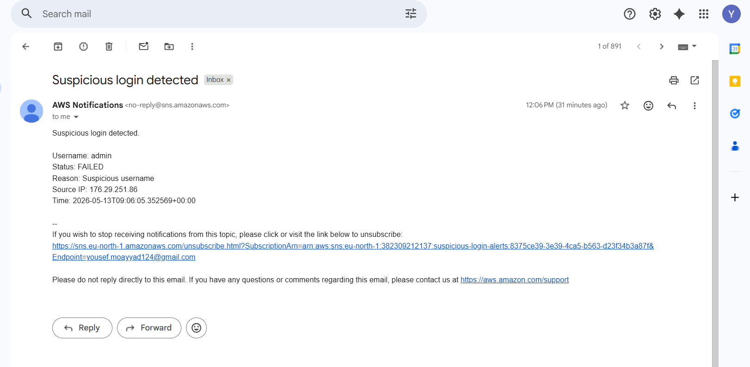
Figure 8. Email alert generated for a suspicious login attempt.

As shown in Figure 9, CloudWatch logs store execution details for the Lambda function, which helps with monitoring, debugging, and verifying that the system is running correctly.
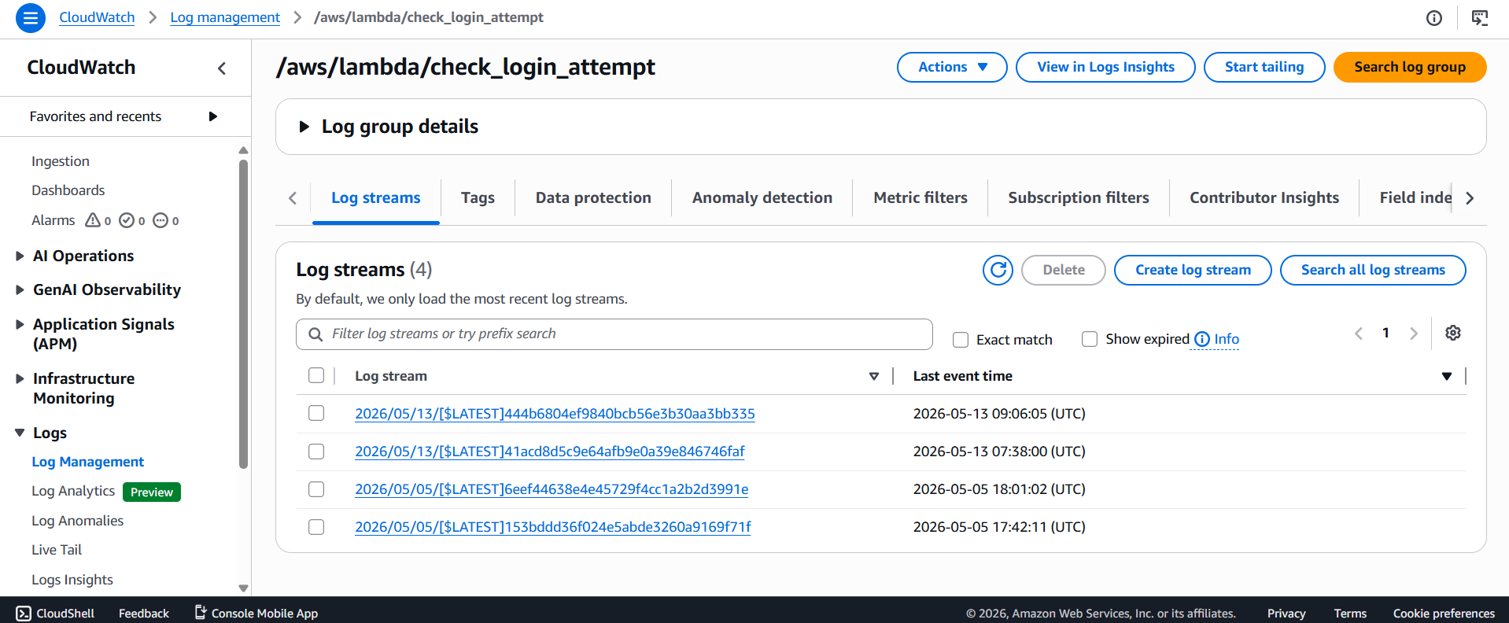
Figure 9. CloudWatch log events generated by Lambda function execution.

4. Security Analysis

4.1 IAM, Encryption, and Secure Communication
IAM was used through the Lambda execution role and custom permissions that allowed the function to write to DynamoDB, publish to SNS, and write logs to CloudWatch. This follows the principle of least privilege, because the function was only given the permissions needed for its task. Secure communication was provided through HTTPS between the browser and API Gateway. For data at rest, DynamoDB encrypts stored customer data at rest, and Lambda environment variables are encrypted at rest with AWS KMS-managed encryption by default. These controls helped reduce the risk of exposing stored data and configuration values.

4.2 Main Risks and Mitigation Strategies
Risk | Why It Matters | Mitigation Used
Repeated failed logins | May indicate brute-force or password-guessing behavior. | The Lambda function checks for repeated failed attempts in a short time window and marks them as suspicious.
Suspicious usernames | Common attacker usernames such as admin and root are frequently tested. | The function flags a predefined set of suspicious usernames.
Abnormal input length | Unusually long values may suggest malicious or abnormal input. | The function flags usernames or passwords longer than the configured threshold.
Lack of visibility | Without logs, failures and suspicious events are hard to investigate. | CloudWatch logs record Lambda execution details.
No administrator notification | Suspicious behavior may be missed if no alert is sent. | SNS sends an email to the administrator when suspicious access is detected.
Excessive service permissions | Overly broad permissions increase the impact of compromise. | IAM roles and policies were limited to required actions.

4.3 Security Tests Performed
Security-related testing focused on rule-based suspicious access detection. A login using the username admin with an incorrect password was marked as suspicious and generated an SNS email alert. The stored record in DynamoDB and the alert email together confirmed that detection, storage, and notification were all functioning correctly.

5. Evaluation and Testing

5.1 Functional Testing
Test Case | Input | Expected Result | Actual Result | Status
TC1 | username=yousef, password=123456 | Login succeeds and is not suspicious. | Result showed SUCCESS, suspicious = No, and data was stored in DynamoDB. | Pass
TC2 | username=admin, password=wrong | Login fails and is marked suspicious. | Result showed FAILED, suspicious = Yes, and an email alert was sent. | Pass
TC3 | Suspicious attempt records | Suspicious attempts should be stored for review. | DynamoDB contained multiple admin attempts marked suspicious = true. | Pass
TC4 | Execution logging | System should generate logs for requests. | CloudWatch showed START, END, and REPORT entries for function invocations. | Pass

5.2 Performance or Scalability Results
A formal load test was not performed in this prototype. However, the CloudWatch log records showed that recent Lambda invocations completed successfully with short execution times visible in the REPORT entries. The observed durations were low enough for the small test workload used in this project, which indicates that the serverless design is suitable for lightweight monitoring tasks. For future work, larger-scale automated testing could be used to measure concurrent login traffic more rigorously.

5.3 Security Testing Results
The suspicious username test clearly demonstrated the security workflow. The system flagged the request, stored it in the database, wrote execution logs, and sent an alert email. This shows that the main detection and response chain worked as intended from end to end.

6. Challenges and Lessons Learned

6.1 Technical Challenges
- API Gateway and Lambda integration needed careful setup so that the request body and HTTP method were passed correctly.
- Cross-Origin Resource Sharing (CORS) caused frontend connection problems during local testing and had to be fixed by adding the correct CORS settings and an OPTIONS route.
- AWS resources were sometimes viewed in the wrong region, which briefly made services such as DynamoDB appear missing.
- SNS permissions had to be added manually so that Lambda could publish email alerts.

6.2 What Worked and What Did Not Work
The final serverless workflow worked well. The frontend, API Gateway, Lambda, DynamoDB, CloudWatch, and SNS were all connected successfully. The most difficult part was the local frontend-to-API connection because browser security settings blocked requests until the CORS configuration was corrected. The project did not include a formal CI/CD pipeline in the final implementation.

6.3 What Could Be Improved
The suspicious-access logic could be improved by adding IP-based rate limiting, stronger account lockout behavior, better credential storage, and a hosted frontend instead of a local test page. A future version could also add a dashboard, stronger authentication controls, containerized frontend deployment, and a CI/CD pipeline.

7. Conclusion
This project successfully implemented a cloud-based login monitoring and suspicious access alert system using AWS services. The prototype demonstrated an end-to-end workflow in which a login request was processed through API Gateway and Lambda, stored in DynamoDB, logged in CloudWatch, and used to trigger an SNS email alert when suspicious activity was detected. The design satisfied the main project goals by combining cloud computing, security monitoring, logging, and alerting in one system.
The final result is not a full production authentication platform, but it is a practical and understandable security prototype. It shows how serverless cloud services can be used together to monitor login activity and react to risky behavior in real time.

8. References
[1] Amazon Web Services, “API Gateway HTTP APIs,” AWS Documentation. [Online]. Available: https://docs.aws.amazon.com/apigateway/latest/developerguide/http-api.html.
[2] Amazon Web Services, “Create AWS Lambda proxy integrations for HTTP APIs in API Gateway,” AWS Documentation. [Online]. Available: https://docs.aws.amazon.com/apigateway/latest/developerguide/http-api-develop-integrations-lambda.html.
[3] Amazon Web Services, “Tutorial: Using Lambda with API Gateway,” AWS Documentation. [Online]. Available: https://docs.aws.amazon.com/lambda/latest/dg/services-apigateway-tutorial.html.
[4] Amazon Web Services, “Getting started with DynamoDB,” AWS Documentation. [Online]. Available: https://docs.aws.amazon.com/amazondynamodb/latest/developerguide/GettingStartedDynamoDB.html.
[5] Amazon Web Services, “Core components of Amazon DynamoDB,” AWS Documentation. [Online]. Available: https://docs.aws.amazon.com/amazondynamodb/latest/developerguide/HowItWorks.CoreComponents.html.
[6] Amazon Web Services, “DynamoDB encryption at rest,” AWS Documentation. [Online]. Available: https://docs.aws.amazon.com/amazondynamodb/latest/developerguide/EncryptionAtRest.html.
[7] Amazon Web Services, “Sending Lambda function logs to CloudWatch Logs,” AWS Documentation. [Online]. Available: https://docs.aws.amazon.com/lambda/latest/dg/monitoring-cloudwatchlogs.html.
[8] Amazon Web Services, “Amazon SNS email subscription setup and management,” AWS Documentation. [Online]. Available: https://docs.aws.amazon.com/sns/latest/dg/sns-email-notifications.html.
[9] Amazon Web Services, “Creating an Amazon SNS topic,” AWS Documentation. [Online]. Available: https://docs.aws.amazon.com/sns/latest/dg/sns-create-topic.html.
[10] Amazon Web Services, “Securing Lambda environment variables,” AWS Documentation. [Online]. Available: https://docs.aws.amazon.com/lambda/latest/dg/configuration-envvars-encryption.html.
[11] OWASP Foundation, “Authentication Cheat Sheet,” OWASP Cheat Sheet Series. [Online]. Available: https://cheatsheetseries.owasp.org/cheatsheets/Authentication_Cheat_Sheet.html.
[12] OWASP Foundation, “Blocking Brute Force Attacks,” OWASP. [Online]. Available: https://owasp.org/www-community/controls/Blocking_Brute_Force_Attacks.

9. Appendices

Appendix A: Lambda Configuration
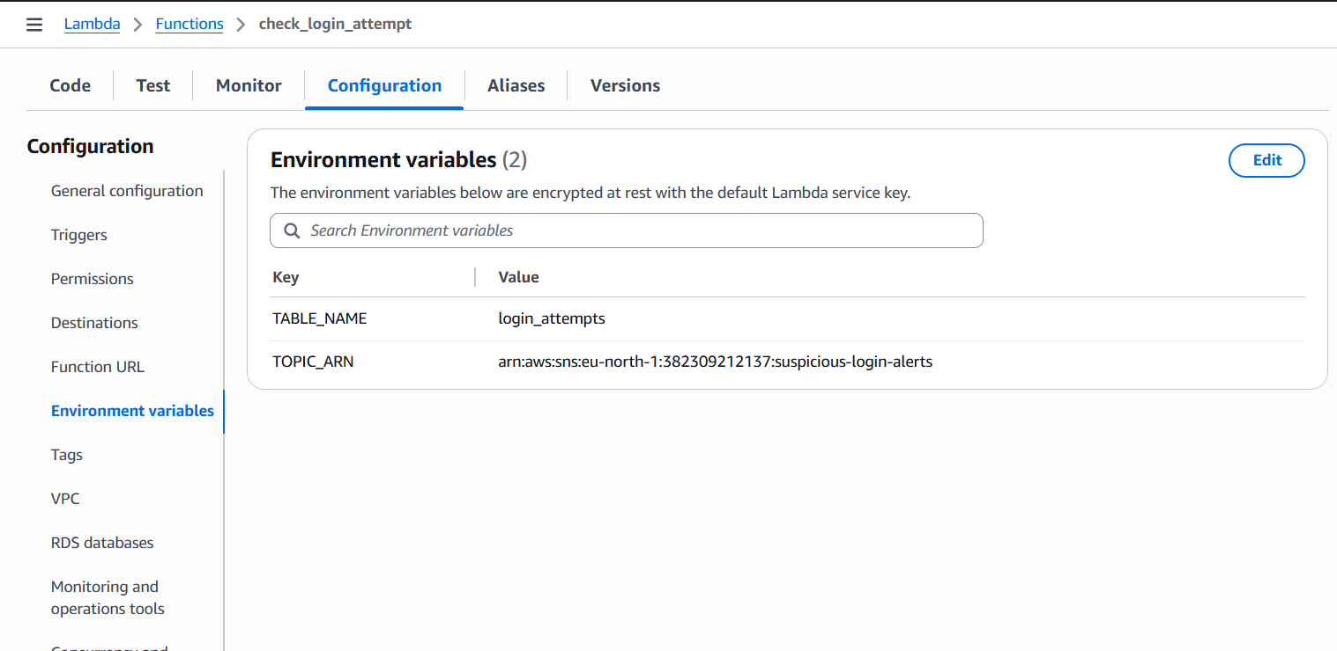
Appendix Figure A1. Lambda environment variables used in the implementation.

Appendix B: Permissions and Policies
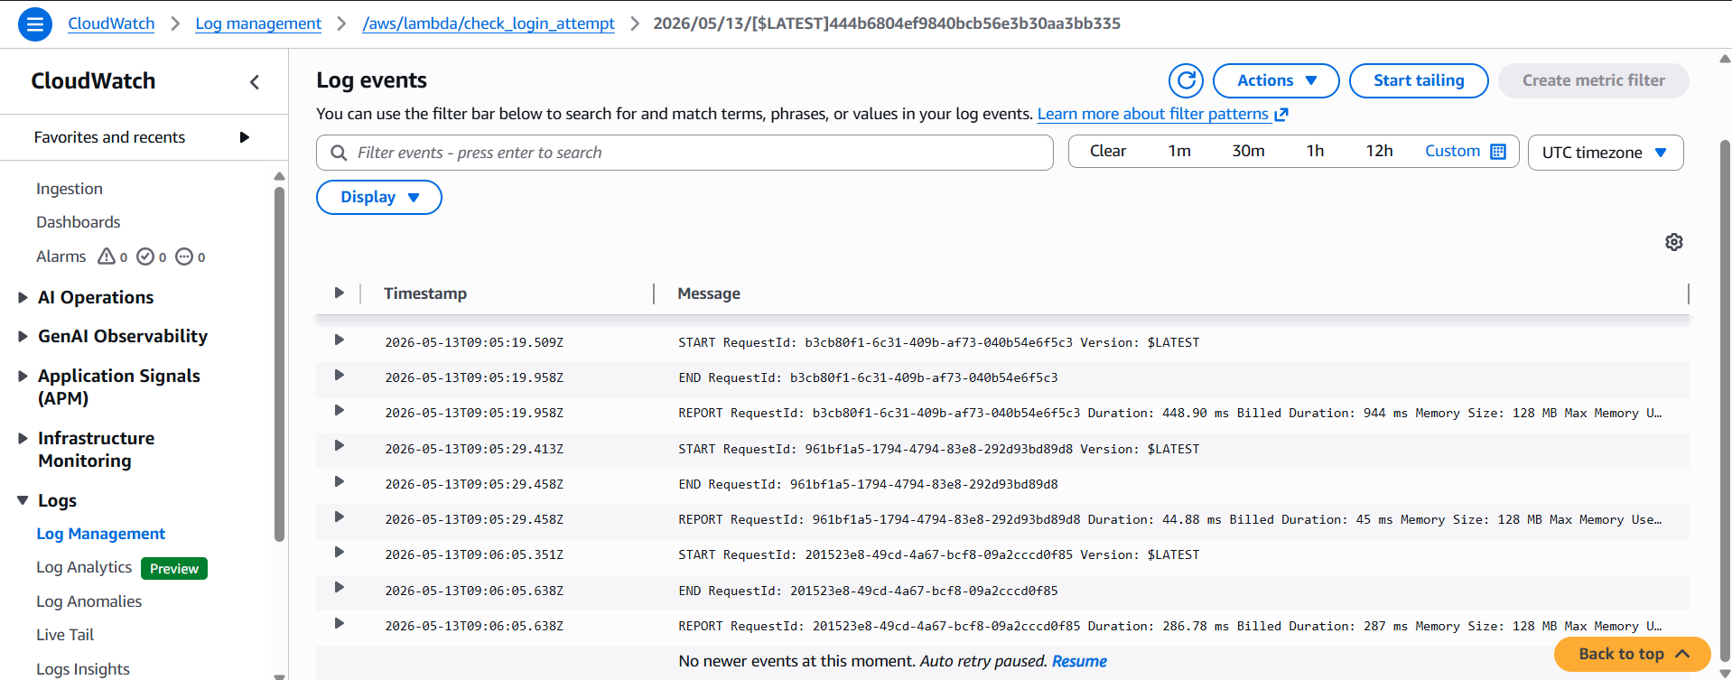
Appendix Figure B1. CloudWatch logs showing execution events for the check_login_attempt Lambda function.

Appendix C: API Deployment Details
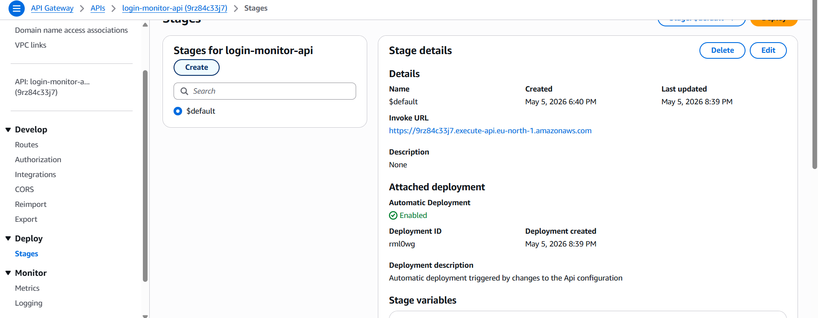
Appendix Figure C1. API Gateway stage details and invoke URL.
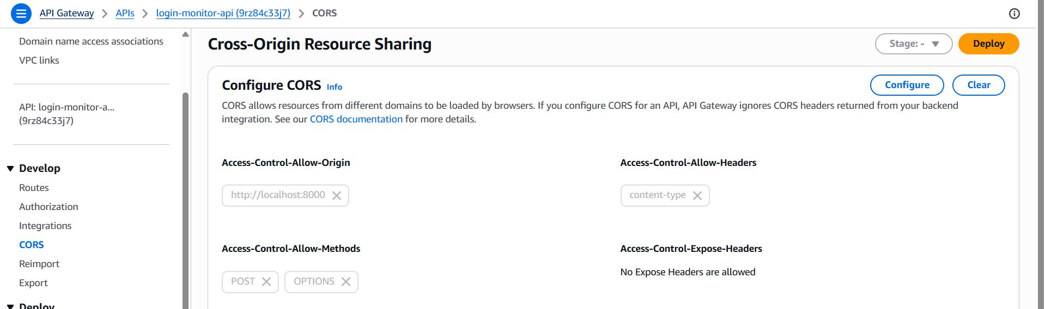
Appendix Figure C2. Final API Gateway CORS configuration for local frontend testing.

Appendix D: Local Testing Setup
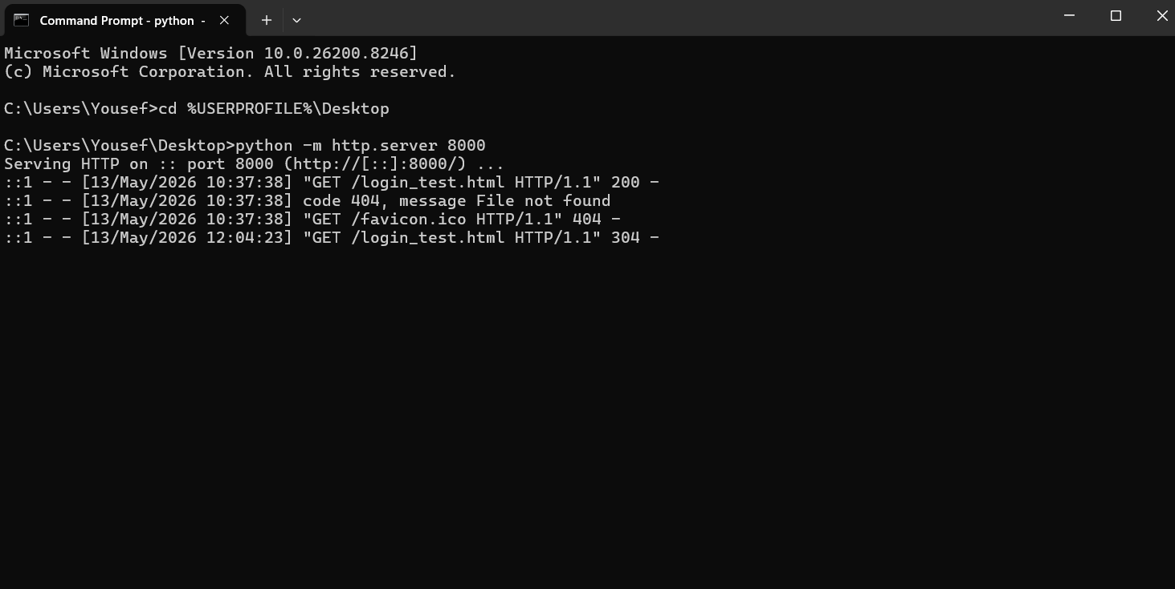
Appendix Figure D1. Local Python HTTP server used to serve the frontend page during testing.

Appendix E: Code Snippets

Appendix Snippet E1. Lambda response and CORS handling
This function builds the JSON response returned by Lambda and includes the CORS headers needed for communication between the frontend and backend.
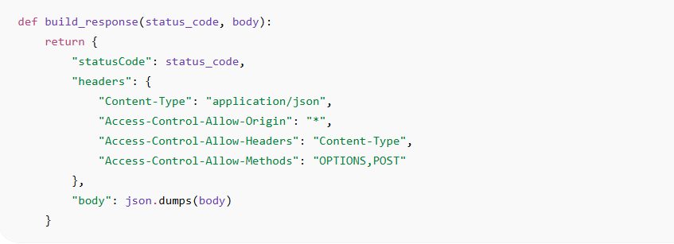

Appendix Snippet E2. Lambda handler starts and request processing
This part of the Lambda function handles incoming requests, processes preflight browser requests, and extracts the username, password, and source IP.
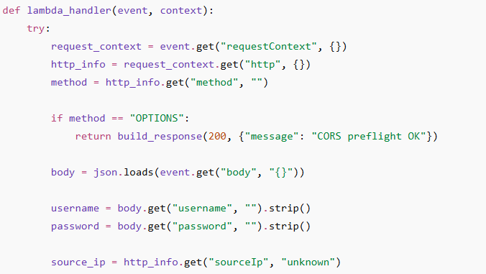

Appendix Snippet E3. Suspicious username and long input detection
This snippet shows the prototype credentials and two important suspicious-access rules: common attacker usernames and unusually long input values.
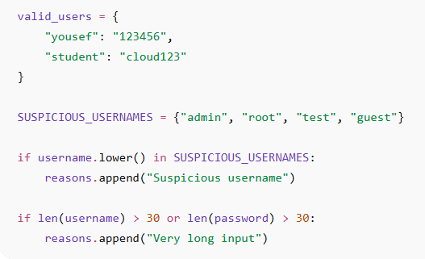

Appendix Snippet E4. Repeated failed attempt detection
This logic checks previous login attempts stored in DynamoDB and flags repeated failed attempts within a short period of time.
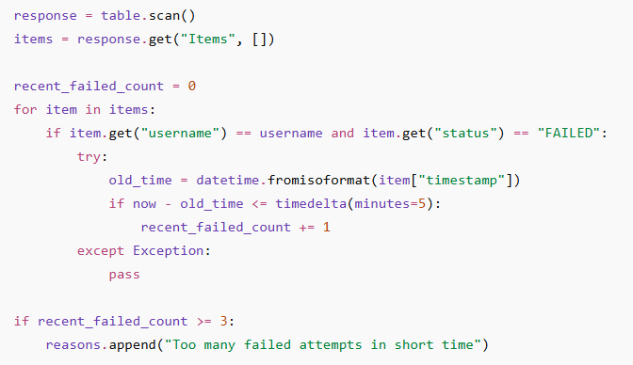

Appendix Snippet E5. Saving login attempts in DynamoDB and sending SNS alert
This snippet stores the login attempt in DynamoDB and sends an email alert through SNS when suspicious activity is detected.
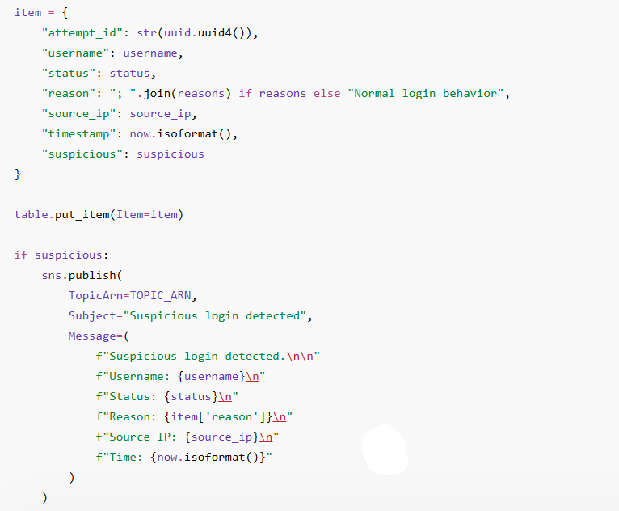

Appendix Snippet E6. Frontend JavaScript request to API Gateway
This JavaScript function sends the login request from the frontend to API Gateway and displays the returned result on the page.
